

(Vision for the Future)

**College of Arts and Applied Sciences**

**Department of Computer Science**

**CMPS 449 – Final Year Project I**

**Traffic Sign Detection**

By

|  |  |
| --- | --- |
| **201910113**  **201910479**  **201910199** | **Shmookh Nasser Ghawas**  **Azza Adel Bait Dashisha**  **Shamukh Abu Baker Alfaqih Alhamiri** |

**Final Year Project Proposal Submitted to the College of Arts and Applied Sciences, Dhofar University, in Fulfilment of the Requirement for the Degree of**

**Bachelor of Science in Computer Science**

**Dec Jan-2023**

**Fall 23-24**

**Supervised By:**

**Mr. Mukesh Madanan**

**Appendix J: Declaration Form**

**DECLARATION**

I/Wehereby declare that the proposal is my/our original work except for quotes and citations that have been appropriately acknowledged. I/We also declare that it has not previously been submitted and is not currently being submitted for any other degree at Dhofar University or any other institution. This proposal report may be made available within the university library and maybe photocopied and loaned to other libraries for consultation.

(Signature)

____________________

**Shmookh Nasser Ghawas**

Date:

(Signature)

____________________

**Azza Adel Bait Dashisha**

Date:

(Signature)

____________________

**Shamukh Abu Baker Alfaqih**

**Alhamiri**

Date:

**Appendix K: Table of Contents**

**TABLE OF CONTENTS**

**Appendix K: Table of Contents** 3

**Appendix L: List of Tables** 5

LIST OF TABLES 5

**Appendix M: List of Figures** 6

LIST OF FIGURES 6

**Appendix M: List of Abbreviations** 7

LIST OF ABBREVIATIONS 7

CHAPTER 1 8

1.1. INTRODUCTION 8

1.1.1. Background 8

1.1.2. Problem Statement 8

1.1.3. Objectives 9

1.1.4. Project Questions 9

1.1.5. Scope of the Project 9

1.1.6. Project Contributions 10

1.1.7. Limitation 11

1.1.8. Conclusion 12

CHAPTER 2 13

2.1. LITERATURE REVIEW 13

2.1.1. Introduction 13

2.1.2. Literature Review 1 14

2.1.3. Literature Review 2 - Models of methodology 16

2.1.4. Conclusion 18

CHAPTER 3 19

3.1. METHODOLOGY 19

3.1.1. Introduction 19

3.1.2. Model Used – For example: ADDIE Model 19

3.1.3. Tools Used 28

3.1.4. Conclusion 28

CHAPTER 4 29

4.1. PROJECT PLAN 29

4.1.1. Project Plan 29

4.1.2. Gantt Chart 30

4.1.3. Network Diagram 30

CHAPTER 5 31

5.1. SOFTWARE REQUIREMENTS SPECIFICATION 31

5.1.1. The Project Purpose: 31

5.1.2. The Project Scope: 31

5.1.3. The Project Functional Requirements: 31

5.1.4. The Project Non –Functional Requirements: 31

5.1.5. Resource Requirements: 34

CHAPTER 6 35

6.1. THE DESIGN OF THE PROJECT 35

REFERENCES 36

**Appendix L: List of Tables**

# LIST OF TABLES

Table 1.1: Limitation on Other Projects and Solutions Given by the Project.

Table 3.1: Table of Market Testing.

Table 3.2: Hardware and Software Requirements.

Table 3.3: The precision of discovery and the contrast evaluation's efficiency.

Table 3.4: Categories of traffic sign used in Oman.

Table 3.5: The value of RGB for every color.

**Appendix M: List of Figures**

# LIST OF FIGURES

Figure 2.1: Picture of Tesla car.

Figure 2.2: understanding the concept of CNN.

figure 2.3: The architecture of CNN.

Figure 3.1:ADDIE Model.

Figure 3.2: Analysis Phase.

Figure 3.3: Design Phase.

Figure 3.4: Development phase.

Figure 3.5: Implementation phase.

Figure 3.6: Evaluation phase.

Figure 3.7: Oman obligatory signs.

Figure 3.8: Oman warning signs section 1.

Figure 3.9: Oman warning signs section 2.

Figure 3.10: Oman preventive signs.

Figure 3.11: Oman Indicative signs.

Figure 4.1: Project Plan.

Figure 4.2: Gantt Chart.

Figure 4.3: Network diagram.

Figure 5.1: Resource requirements.

Figure 6.1: The design of the project.

**Appendix M: List of Abbreviations**

# LIST OF ABBREVIATIONS

CNNs Convolutional Neural Networks

YOLO You Only Look Once

TSR Traffic Sign Recognition

IDAS Intelligent driver assistance system

GTSRB German Traffic Sign Recognition Benchmark

SSD The Sign Shot Multibook Detector

ADAS Advanced Driver Assistance Systems

SVMs Support Vector Machines

AI Artificial Intelligence

RGB Red Greenand Blue

# CHAPTER 1

## INTRODUCTION

### Background

The systems of traffic management and the safety of the road are very significant elements that the world is looking for. Many countries around the world suffer from a huge number of accidents and this can occur by the fault of the driver or because of another reason [1]. The project aims to detect the traffic sign in order to increase the safety of humans, and to reduce the number of accident. The project will provide a solution to decrease the accident number by using algorithms of computer vision in order to detect the traffic sign efficiently in real-time.

The purpose of the project is to layout a system that recognizes or detects an extensive number of traffic signs. The system will be able to detect the stopping signs, the limit speed signs, in addition to the warning signs. By using techniques of object detection entrenched algorithms of image processing and by the methods of machine learning which are operating on detecting these signs in real-time [2]. The crucial goal of detection of traffic sign is to maximize the attention of drivers to the existence of traffic signs in their vicinity and aids to enhance the safety and decrease the range of accident by providing accurate information about regulations and rules of traffic [3].

Moreover, detecting the signs of traffic is not easy, it is considered as a challenging issue for several reasons such as different occlusions, perspectives, and lighting conditions [3]. the techniques of machine learning and the advances in algorithms of computer vision, both have allowed the evolution of more accurate detection systems.

In the end, this system is helpful in enhancing the safety on the road. Also, it is beneficial for the drivers in making optimal decisions, and in decreasing the accident risk.

### Problem Statement

This project aims to design a system that works on increasing the safety in road and the skill of driver. The problem is that there are several systems this day that operate on detecting the signs of the traffic depend on existing techniques of computer vision so the ability of them is limited [4]. varying traffic signs have varying colors and shapes, and because they are occasionally invisible to vehicles, they frequently cause misunderstanding and accidents [4]. The goal of this project is to create a sophisticated and effective system that detects traffic signs properly and effectively.

Additionally, this research will make use of object detection frameworks (You Only Look Once, or YOLO) and convolutional neural networks (CNNs) for deep learning models [5]. The technology will be able to generalize to a variety of shapes and colors using databases of traffic signs. In order to make the system compatible with a variety of hardware and platforms, it will also function with various cameras and sensors.

### Objectives

Creating a reliable and accurate system for automatic traffic sign interpretation and identification is the main goal of the Traffic Sign identification (TSR) system project. The following are the project's main goals:

1. Enhancing road safety
2. Accuracy: demonstrate a high degree of accuracy when identifying and categorizing many kinds of traffic signs, including regulatory and warning signals
3. Provide drivers relevant data.
4. Promoting the recognition of traffic laws in real-time.

### Project Questions

During the creation and implementation of a Traffic Sign Recognizer (TSR) system project, a number of key questions and considerations usually come up. These inquiries include a wide range of project topics, such as practical, technological, and user-focused issues. A TSR system project may have the following important project questions:

1. What are the specific requirements for traffic sign recognition?
2. What is the most suitable approach for image processing and computer vision?
3. How can the system be trained and validated with diverse and representative datasets?

### Scope of the Project

A broad range of practical, technological, and user-focused goals are included in the scope of the Traffic Sign Recognition (TSR) system project. The project scope outlines the parameters and goals of the TSR system as well as the features, capabilities, and deliverables that will be part of the work, including:

1. Identification and detection of traffic signs: The main goal of the project is to create a system that can reliably identify and detect various kinds of traffic indicators, such as warning, regulation, and informational signs.

2. . Image analysis: Using image processing methods to examine visual information obtained by the car's installed cameras is part of the scope.

### Project Contributions

The project makes a significant contribution to safer communities in a number of ways, including technological innovation, increased traffic protection, enhanced user experience, and societal benefits. Contributions to the project are as follows:

1. Right Now, Traffic Sign Detection and Live Detection While Driving: This feature makes use of the car's vision system to recognize and analyses traffic signals while it is moving. [6]

2. The Data Collection and Utilization: Phase of Data Collection and Training: In this phase, a great deal of traffic signal data is gathered, and the system is rigorously trained to identify signals with a high degree of precision. [6]

3. Better Protection Procedures: Increasing Traffic Safety The project's primary goal is to significantly raise road safety by enabling accurate and dependable traffic signal recognition, which will make streets safer for both vehicles and humans. [6].

#### Technological Input

1. Benchmark Development and Enhance: Creating and refining benchmark datasets is an important development in the field of traffic sign recognition. The creation of benchmarks, such the Tsinghua-Tencent 100K Benchmark, is one noteworthy advancement in specific. [5,22] The meticulous selection of a huge dataset more in terms of quantity and quality of photos than its predecessors set this benchmark apart. [5,22] It features a large array of realistic settings that are depicted in the real world, including numerous roadway situations that tell lighting conditions, weather, and occlusion scenarios. [5,22] Since it is able to replicate the intricacies of actual road environments, this benchmark is superior due to the fact that it provides traffic sign detection algorithms with a more challenging and accurate information for learning on. [5,22] By accounting for a variety of environmental factors, it enables the development and testing of algorithms that are more robust and adjustable to current conditions. [5,22] This improves system dependability and detection accuracy significantly. [5,22] Furthermore, it remains imperative to maintain benchmarks like as the Tsinghua-Tencent 100K Benchmark, which are always improving. [5,22] The dataset is updated, refined, and added to on a regular basis to keep it current with changing road conditions and reflective of the most recent difficulties with traffic sign detection. This ongoing improvement is essential to the field's innovation and the creation of more dependable and effective traffic sign detection systems. [5,22]

2. Specific CNN Models: Customized CNN Models: Convolutional Neural Networks (CNNs) with a strong performance in handling real-world scenarios have been trained for traffic sign identification and classification tasks. [6]

### Limitation

|  |  |
| --- | --- |
| **Limits on Other Projects** | **Solutions Given by the Project** |
| **Short Dataset:**  A lot of current projects have insufficient datasets, which limits the variety of traffic sign photos that can be utilized for training and lowers accuracy and generalization power.[7] | In order to provide reliable model training and higher performance across a variety of scenarios, the project aims to generate a large dataset including a wide range of real-world traffic signals under varying settings (different lighting, weather, occlusion). |
| **Environmental Changes:**  Different environmental variables, such as different lighting intensities, unfavorable weather, and occlusions, make it difficult to recognize signs effectively and reduce detection accuracy.[7] | The goal of the project is to improve the model's capacity to manage a variety of environmental circumstances and provide dependable detection in a range of scenarios by creating adaptive algorithms and utilizing cutting-edge training methodologies. |
| **Limited Sign Choices:**  While some efforts concentrate on frequently seen signs, they frequently ignore less common or regionally specialized signs, which restricts the system's application in a variety of geographic locations.[7] | The project seeks to augment the system's versatility and usefulness across different locations by incorporating a complete collection of less common signs, including regional variations. |
| **Single Sign Detection:**  Certain systems can only identify a single sign at a time and are unable to identify numerous signs at once within a scene, which restricts the overall comprehension of the situation and the potential for safety precautions.[6] | The goal of the project is to create models that can identify several signals in a single shot, enhancing safety and general scene awareness. |

Table 1.1: Limitation on Other Projects and Solutions Given by the Project.

### Conclusion

This project aims to solve a problem, which is traffic signal detection. Some pedestrians may not know what the signals in front of them mean, and some accidents may occur when the signals are neglected and not understood. This project addresses this problem by using computer version and machine learning techniques. It is also working to develop and improve road safety and manage traffic and transportation properly. It always seeks to provide an appropriate and practical solution for automatic detection of traffic sign.

# CHAPTER 2



## LITERATURE REVIEW

### Introduction

Road sign recognition plays a critical role in modern transportation systems such as the intelligent driver assistance system (IDAS). It is crucial for improving highway security, reducing crashes, and enhancing traffic management. The literature on traffic sign detection is examined in the following section, along with information on its background, significance, and variety of methods and models applied in this field.

#### The Evaluation of Traffic Sign Detection

#### The beginnings of identifying traffic signs can be connected to the early phases of computer vision and image processing technology[8]. Through the years, this field has experienced considerable growth and transformation.[8] Traditionally, the cornerstone of classic computer vision techniques used for traffic sign detection was individual features and rule-driven approaches. Even though they were groundbreaking at the time, these early systems typically failed in practical settings because to weather variations, illumination shifts, and substantial deterioration. [8]

#### As machine learning and deep learning advanced, there was a discernible shift towards data-driven methodologies[8]. The networks of neural networks were first used by scientists to address the difficult issue of traffic sign detection.[8] Deep learning architectures like Convolution Neural Networks (CNNs) started to take center stage.[8] Under the most challenging situations, such algorithms showed remarkable component comprehension and noteworthy accuracy in roadway sign detection[8]. Big data sets such as the German Traffic Sign Recognition Benchmark (GTSRB) have simplified developing these models easier [8].

#### The use of algorithms for detecting objects greatly improved the speed and accuracy of traffic sign detection.[8] Recognizing several traffic signs in photographs and footage in context is rendered possible by the Sign Shot Multibook Detector (SSD) and You Only Look Once (YOLO) technologies.[8] The integration of detection of road signs software and advanced driver assistance systems (ADAS) in autonomous vehicles was made feasible by these technological advances. [8]

#### The Significance of Traffic Sign Detection

It is impossible to overstate the significance of traffic sign detection. The main method. Road signs are the primary means of informing alert drivers of important to critical information while they are driving is through traffic signs.. [9] They offer the guidelines, states, and rules that are required for safe and effective transportation. [9] Traffic management systems depend on the accurate and quick recognition of these warning signs.[9]

Traffic sign detection can improve driver awareness and reactivity in urban settings with high rush hour traffic and complicated crossing. It helps the drivers to follow traffic laws by making it easier for them to see stop signs, yield signs, speed restrictions, and other legal signs. [9] For example, a car’s braking system may activate automatically upon detecting a stop sign, reducing collisions at intersections. [9]

Traffic sign detection is equally useful in highway conditions. It helps cars follow diversion directions, navigate around building areas, and maintain a safe speed. It can also give drivers information about local services like restaurants, petrol stations, and rest spots. [9]

Traffic sign detection affects smart city projects in addition to road safety. [9] It could be helpful in gathering traffic data, which can assist cities keep an eye on and improve traffic flow.[9] Additionally, it advances the development of autonomous cars by providing them with the data needed to operate on their own road systems. [9]

### Literature Review 1

For a traffic sign detection project, a literature study entails a thorough examination of previous studies and publications on the subject of technologically aided traffic sign detection, usually within the fields of computer vision and image processing. This is what it comprises:

1. Review of Related Research: Locate and gather scholarly works, technical reports, and articles that discuss the use of cameras, image processing methods, and machine learning for traffic sign detection.

2. Summary of Key Findings: Provide an overview of the primary conclusions, approaches, and results from the chosen research articles. This could involve going over the many kinds of traffic signs that are found, how accurate they are found, and what models or algorithms are used.

3. Comparative Analysis: Evaluate and contrast various traffic sign technologies, methods, and approaches. With the use of this study, project leaders can have a greater awareness of the benefits and drawbacks of various detection techniques.

4. Stress Scientific Advancements: Describe any noteworthy advancements in algorithms for deep learning, actual time detection technology, or efficiency advances in the field of identifying traffic signs technologies.

5. Analyses Barriers and Limits: Discuss the challenges and limitations of the existing approaches, such as adverse conditions, signage that are obscured, or demands for processing.

6. Instruct Work Creators: Utilize the information acquired from the scientific review to direct the design of the road sign recognition project, comprising the selection of hardware, software, and detection methods.

#### Detection Techniques:

1. Conventional imaging techniques: Investigate antiquated techniques for traffic signal detection, Examining the use of methodologies for machine learning, that include based learners and more complex algorithms like Support Vector Machines (SVMs) for traffic sign recognition.

2. In the context of traffic sign recognition systems, data analysis is a key detecting method. It is essential for making sense of and drawing insightful conclusions from the imagery that detectors and cameras record. The key elements of this analytical procedure include feature extraction and classification, data fusion analysis, image processing and pattern recognition, and removal of features.

3. Deep Learning Approaches: apply deep learning techniques, especially convolutional neural networks (CNNs), to automatically extract and recognize features.

4. Typical structures:

- CNN Architectures: Validation of different CNN architectures specifically designed for TSR. By conducting a comprehensive literature review, the project can build on existing knowledge in the field, identify gaps, and create a solid foundation for designing and implementing an effective TSR system.

#### COMPANIES USE (TSR) IN THEIR VEHICLES:

Tesla: Autopilot is an advanced driver assistance technology that comes standard on Tesla automobiles. Autopilot incorporates technologies like Traffic-Aware Cruise Control and Auto-steer, which use camera and sensor data to analyze traffic signs and control vehicle speed. [13]

Tesla's lane-keeping technology, known as auto-steer, enables the car to stay in its lane

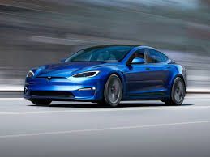

Figure 2.1: Picture of Tesla car. [23]

It recognizes lane markers and navigates the road using a mix of cameras and sensors. [13]. Nowadays, several automotive and technology companies integrate Traffic Sign Recognition (TSR) systems into their vehicles and products. The system will raise traffic safety because of the complex safety system that is included.

BMW: As part of its driver assistance systems, BMW includes TSR. Their technologies interpret and recognize traffic signs using cameras and image processing algorithms, giving drivers pertinent information. [13]

For every firm, the availability of TSR features may varies according on the model and region. The TSR system has a positive impact on the driver and also on traffic security and safety in general. Companies introducing the TSR system improves the company’s reputation in terms of development as well as in terms of security. [13]

### Literature Review 2 - Models of methodology

The developing requirement of this project is an accurate approach. To aims this process, several methodology models have been recommended. This section will investigate approximately the most widespread methods that are used for this project.

Convolutional Neural Networks (CNNs) are one of the most widely used for the tasks of traffic sign detection. CNNs are a kind of model of deep learning. CNNs operate in obtaining features from the input of the images through convolutional layers. In addition, construct precise predictions using the features that are extracted. The models of traffic sign detection using CNN have demonstrated hopeful results in different competitions and studies [10].

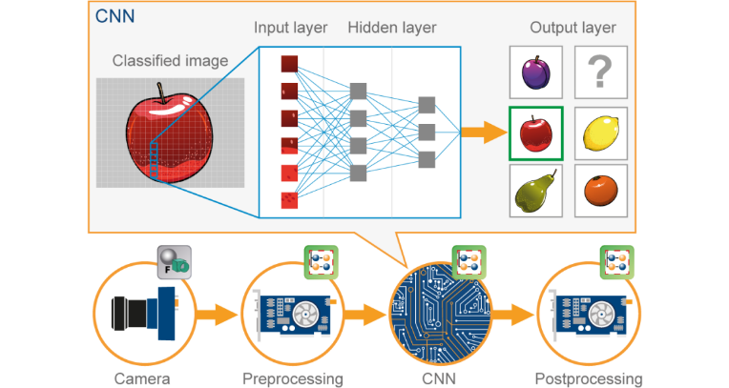

Figure 2.2:Understanding the concept of CNN. [24]

The architecture of CNN's is compared to the pattern of connectivity of the human brain. the humans brain and CNNs are both have common object, which is neurons, but in CNN they are organized in a particular way. Moreover, the neurons of CNN's are organized like the brain's frontal lobe, the area responsible for processing visual stimuli [10].

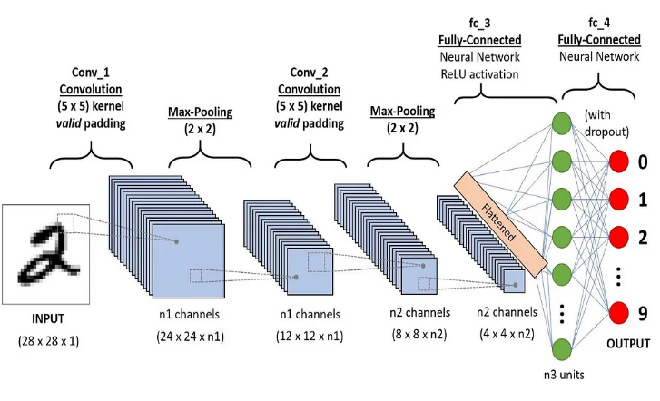

Figure 2.3:The architecture of CNN. [27]

You Only Look Once (YOLO) is a famous framework for detecting object. YOLO is based on deep learning that has obtained considerable attention in tasks of the computer vision, involving the detection of traffic signs [5].

In real-time, YOLO consider one of the most an efficient and faster approaches in object detection by gathering object classification and localization into a one-step [5].The main purpose of YOLO is taking input image and divide them, if an object centre into a cell grid, which cell grid is aimed to detect the object[5]. Each of its guess's boxes of bounding and scores of confidences for these boxes. These scores of confidences indicate how the model is confident in which the box holds an object also how exactly it assumes the prophesied box is [5].

### Conclusion

This section goes into detail about the various approaches and models used in the discipline of traffic sign detection, as well as how much this field has progressed recently. The methods and characteristics of earlier approaches and models had limitations, so as deep learning and machine learning gained traction, researchers attempted to address this issue by employing models like CNNs, YOLO, and SSD, which have several features that make the process of detecting traffic signs easier. The ability to recognize traffic signs has greatly benefited the individual. It promotes greater safety and adherence to traffic laws.

# CHAPTER 3

## METHODOLOGY

### Introduction

The methodology chapter is essential for describing the methodical approach used to accomplish the project's goals. This section explains the methodology used to create a reliable system for detecting traffic signs. Setting the scene, the introduction summarizes the methodology section and emphasizes how important it is to have an accurate and effective traffic sign detection system to improve road safety, control traffic, and facilitate autonomous vehicle navigation.

The importance of the traffic sign-detecting system, especially in the context of modern transportation infrastructure, is summarized in the introduction. It explores the main goals of the project and highlights how important this system is to solve problems with road safety and maintaining efficient traffic flow.

### Model Used – For example: ADDIE Model

The ADDIE approach, which stands for analyze, Design, Develop, Implement, and Evaluate, is a long-lasting framework for instructional design that is applied to the traffic sign detecting project. [30]It serves as a foundation for guidance, supporting methodical reflection on the architecture of the system. [30]Even if the structure of the model appears to be linear, it is not required to follow a strictly linear approach, especially in cases where materials or components for the traffic sign detection system are already established.[30]



Figure 3.1:ADDIE Model. [28]

#### Analysis Phase

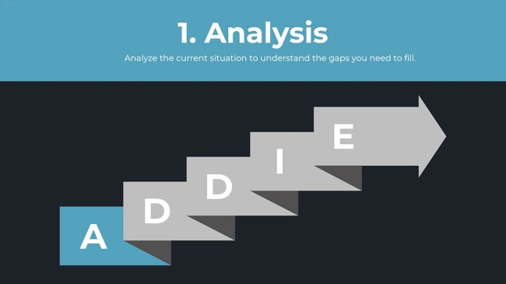

Figure 3.2: Analysis Phase. [28]

The creation of the traffic sign detection system is initiated in this section with a thorough investigation phase. [15] This phase's main objectives are to define the project's requirements, comprehend the demands of stakeholders, and analyses the datasets that are currently available. [15]

Problem Summary: The need to address issues with precise and effective traffic sign detection led to the creation of the project. [15] This section describes real-world problems that traditional detecting systems face, like changes in weather, sign size, and environmental influences. [15]

Market Testing:

A comprehensive stakeholder analysis is used to identify and classify important parties involved in the development and deployment of the traffic sign-detecting system. [15,16] The research looks into the goals, worries, and duties that participants have with regard to how well the system performs. [15,16] Development teams, end users, and regulatory and transportation authorities are examples of customers. [15,16] The Stakeholder Analysis Table displays the obligations, concerns, and targets of the relevant those involved:

|  |  |  |
| --- | --- | --- |
| Stakeholder | Role | Interest |
| Authorities for Transportation | Those who make decisions | Enhance traffic flow and road safety |
| Users of the System | End-users | user-friendly interface, precise outcomes |
| Designers | Project group | robustness and technological innovation |
| Organizations Regulating | makers of policy | respect to traffic laws |

Table 3.1 Table of Market Testing.[15,16]

Gathering and Examining Data:

The process of collecting data involves acquiring a range of datasets containing images of traffic signs shot in various situations, such as varying lighting, the environment, and sign locations. [17] Understanding the issues, diversity, and distribution of the collected dataset is the goal of following statistical analysis.[17]

Requirements for Software and Hardware:

A detailed examination of the necessary hardware and software is an essential part of the analysis phase. [18] This entails outlining the required software, such as the tensor flow algorithm and OpenCV, to implement the algorithms, as well as the hardware requirements, such as high-definition cameras and the specifications for the GPU required for immediate processing.[18]

This table is a list of the software and equipment needed for the structure:

|  |  |
| --- | --- |
| Requirement | Synopsis |
| Cameras with an excellent sensitivity | Take clear photos to identify the signs. |
| GPUs | Processing power in real time for effective identification. |
| An OpenCV or Tensor Flow | Frameworks for machine learning in algorithm implementation. |
| Interface that is easy to use | Detected signs are simply displayed on the live video channel. |

Table 3.2: Hardware and Software Requirements.[18]

#### Design Phase



Figure 3.3: Design Phase[28]

Technology Setting up: A comprehensive design process further develops the architectural framework of the traffic sign detecting system.[19] It goes into great depth about the multiple levels the pipeline, including the steps involved in extraction of features, classification, and picture editing.[19] The interconnections among these stages are highlighted to ensure effective finding and understanding of traffic signs.

Method Choosing: To ascertain which algorithms would be most effective for the detecting task, a comprehensive analysis and evaluation were carried out. [19]The rationale for the utilization of specific Convolutional Neural Network (CNN) architectures, such YOLO and SSD, is thoroughly examined, showcasing their effectiveness in accurately recognizing traffic signs in real-time scenarios.[19]

This table presents an examination of comparison of a few CNN designs, including SSD and YOLO, for detection accuracy and efficiency.[19]

|  |  |  |
| --- | --- | --- |
| The algorithm | Precision | Speed of Processing (FPS) |
| YOLO | YOLO is less precision than SSD. | YOLO is more faster than SSD. |
| SSD | SSD is more precision than YOLO. | SSD is less faster than YOLO. |

Table 3.3: The precision of discovery and the contrast evaluation's efficiency [31]

Validation and Training Models

The methodology for training the models that have been chosen on the acquired information is explained in this piece. [20]It addresses things like model training cycles, evaluation processes, and adaptation techniques. [20] To evaluate the accuracy of the models, performance metrics including F1-score, precision, and recall are employed.

Design of User Interface:

During the user interface design phase, an intuitive interface for displaying the output of the system is created.[21] To ensure end users' ease of use and comprehension, this involves superimposing additional details on top of recognized indicators on the live cam.[21]

#### Development Phase

The aim of this project is to create, design and execute a detection system of traffic signs, that is able in an accurate technique to determine distinctive kind of road signs. To improve the performance, this project will make use of CNNs and YOLO. several methods such as collecting huge amounts of datasets, for example Omani traffic signs, and process them using numerous manner in order to test and train the system[11].



Figure 3.4: Development phase. [28]

#### Implementation Phase

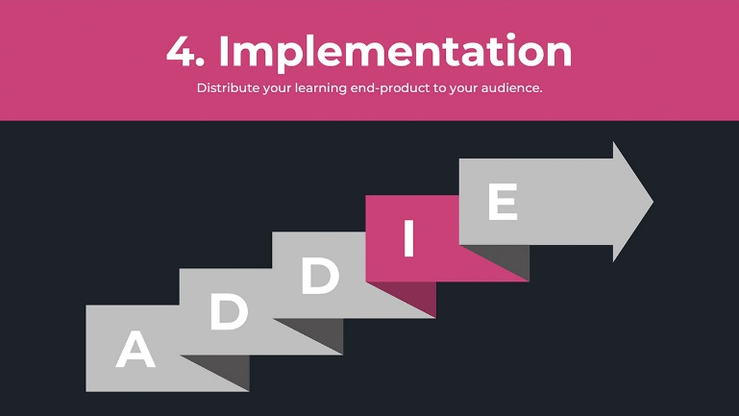

Figure 3.5: Implementation phase. [28]

##### Augmentation of Data:

The project aims to collect huge amounts of data and process them in order to improve the performance of the system. The datasets of images are necessary for detection of traffic signs, it will be used in order to testing and training the models of machine learning[11]. So this type of model is constructed to aim learning from data and make prognosis or decisions depending on this type of data. With the purpose of improving the performance and also the accuracy of these models, it is significant to supply them with a representative and various datasets[11]. The traffic sign of the road in Oman classified into different categories, obligatory signs, warning signs, preventive signs and Indicative signs, maximum-limit sign and in addition to the traffic light as shown in the following figures.

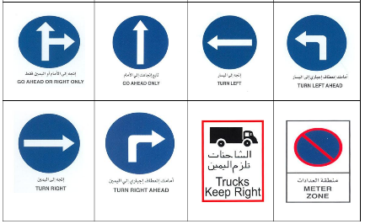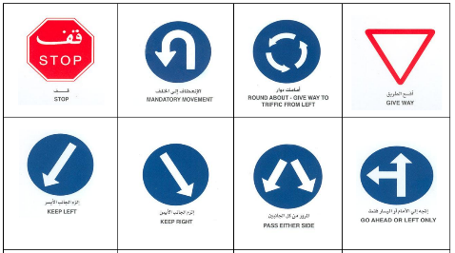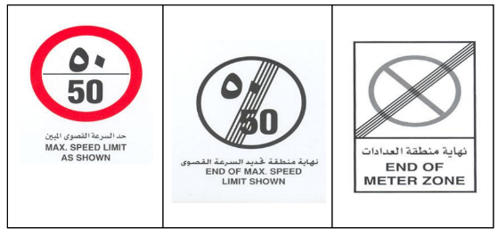

Figure 3.6: Oman obligatory signs. [25]

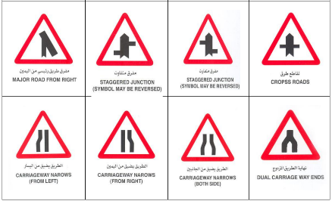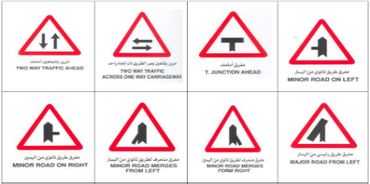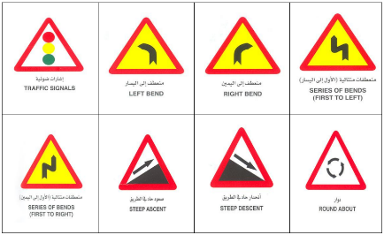

Figure 3.7: Oman warning signs section1. [25]

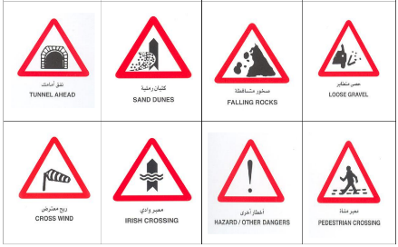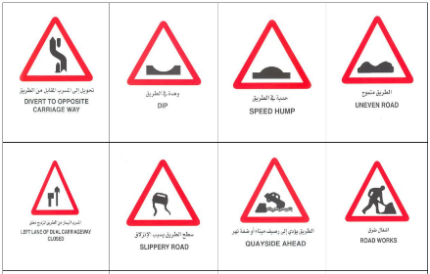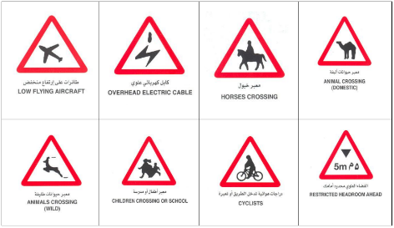

Figure 3.8: Oman warning signs section 2. [25]

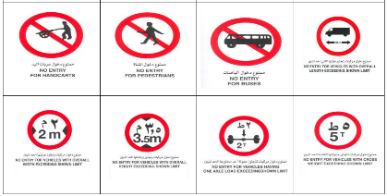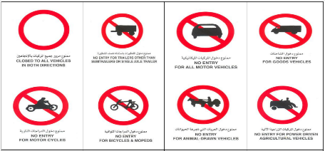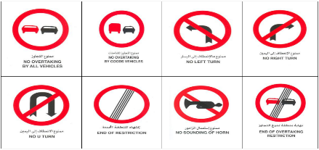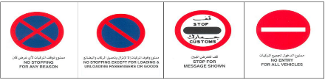

Figure 3.9: Oman preventive signs [25].

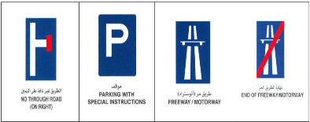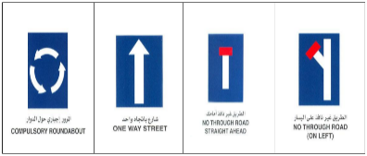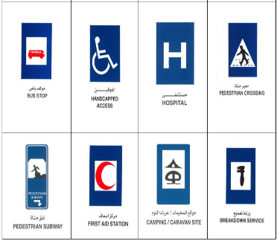

Figure 3.10: Oman Indicative signs. [25]

##### Images Processing:

1. Processing the images is a significant process that aims to upsurge the image quality, eliminate from an image the objects that are undesired[12].
2. Alter the size and cropping: this step aims to decrease the use of the memory and also the computational cost of the project model of AI. In addition, to prevent inconsistency and distortion in the input. Using a method of thumbnail in PIL, the aim of keeping the image aspect ratio while resizing the image to fit inside the given dimensions (obligatory signs, Warning signs, etc..) [12].
3. Normalize the images and standardize it: both of the two techniques aim to upgrade the performance of the model and confirming the data is in a range that is consistent[11]. Normalizing an image of RGB, we will make division on every channel of color by the largest value of it[12]. This leads to scales every value of channels between 0 and 1. Likewise, the process of standardization, we will subtract the mid of every channel then divide it using its normal deviation [12].

In the table 3.4, it demonstrates the type of Omani sign of traffic. In addition, the RGB values for that type of signs are in table 3.5.

|  |  |  |
| --- | --- | --- |
| Categories of traffic sign used in Oman | Instances | |
| Red traffic sign |  |  |
| Blue traffic sign |  |  |

Table 3.4: categories of traffic sign used in Oman.

|  |  |  |  |
| --- | --- | --- | --- |
| THE COLOR | THE VALUE OF RGB | | |
| BLUE | 0 | 0 | 225 |
| RED | 225 | 0 | 0 |
| AMBER | 150 | 70 | 0 |
| YELLOW | 225 | 225 | 0 |
| BLACK | 0 | 0 | 0 |
| WHITE | 225 | 225 | 225 |

Table 3.5: the value of RGB for every color. [29]

1. Applying segmentation: by Appling Semantic segmentation using CCNs. It categorizes each pixel of the image, that lead to a segmented image by class [12].
2. Filtering the images and smoothing it: by using Sharpening filter that aims to upgrade the image contrast and image detail, that aid in facilitating detecting the image [12].

#### Evaluation Phase



Figure 3.11: Evaluation phase. [28]

The aim of this project is to develop a real-time system in the domain of traffic sign detection using techniques of computer vision. The aim is to detect and classify in an accurate manner several types of traffic signs from the image. This project aims to employ methodology such as CNN architecture and YOLO which enhances the accuracy and acceleration of detecting objects in real-time. A dataset of gigantic images collected and augmented with the use of several techniques such as thumbnail, normalization and standardization, applying segmentation, filtering the images and smoothing[12]. In addition, YOLO will be equipped to trained by the utilization of the dataset. The dataset for training is separated into 70%, for validation is separated into 10%, and for testing is 20%.

### Tools Used

#### Hardware

Hardware components consist of: Utilize a high-resolution camera to take images frames of the road and traffic lights.

1. Microcontrollers or single-board computers (SBCs)
2. Sensors: In addition to the camera, use accelerometers or gyroscopes for motion detection and stabilization.
3. Power source: Select a deployable power source that suits your requirements, such as rechargeable batteries or a continuous power supply.[14]

#### Software

##### Development Tools and Software:

- Programming language: Python and C++ will be utilized in this project.

- Computer Vision Library: OpenCV (Open-Source Computer Vision Library) is a powerful and capable library for computer vision tasks. To process images, it provides a set of tools and algorithms.

- Machine learning frameworks.

- Deep Learning Models: utilize pre-trained models or train new models specifically for the project by using datasets of specific traffic light images.

- Image processing tools: By using programs such as GIMP or Adobe Photoshop to pre-process, resize and enhance the image.[14]

### Conclusion

To sum up, creating a traffic sign recognition system requires combining software and hardware elements in order to produce precise and effective results. [14]

# CHAPTER 4

## PROJECT PLAN

### Project Plan

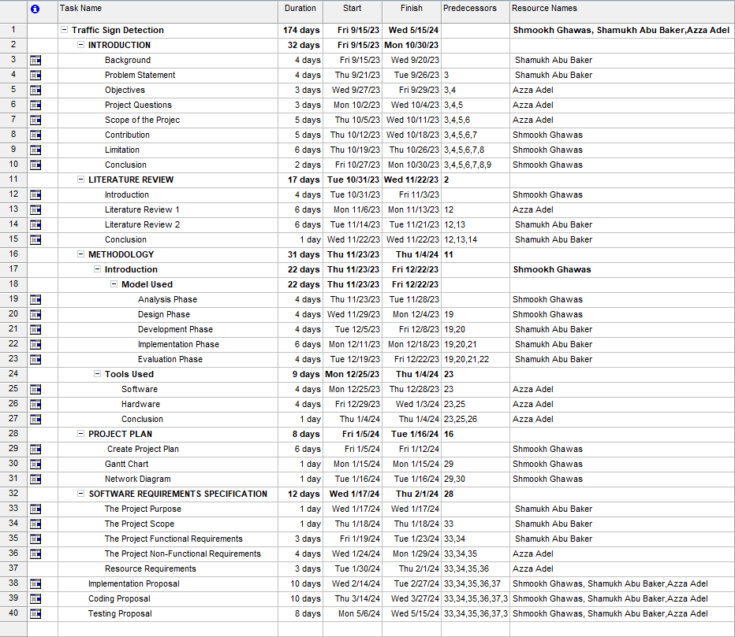

Figure 4.1: Project Plan.

### Gantt Chart

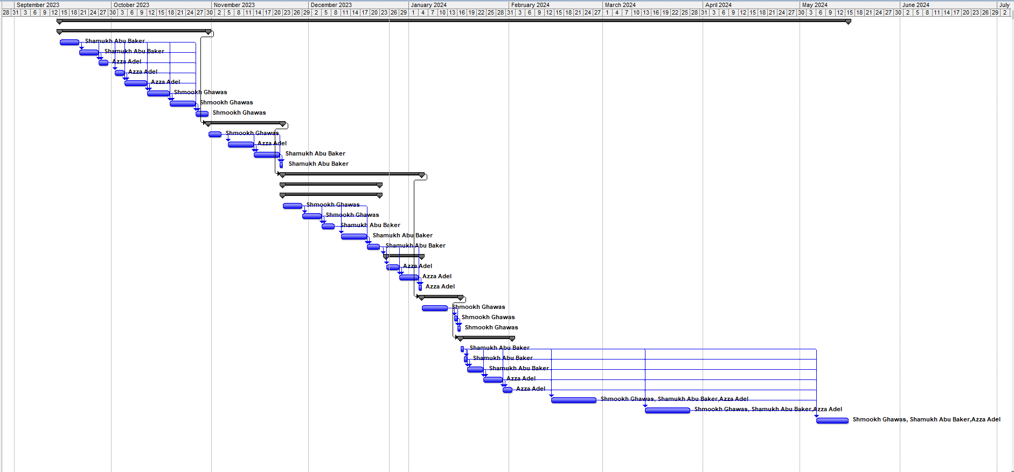

Figure 4.2: Gantt Chart.

### Network Diagram

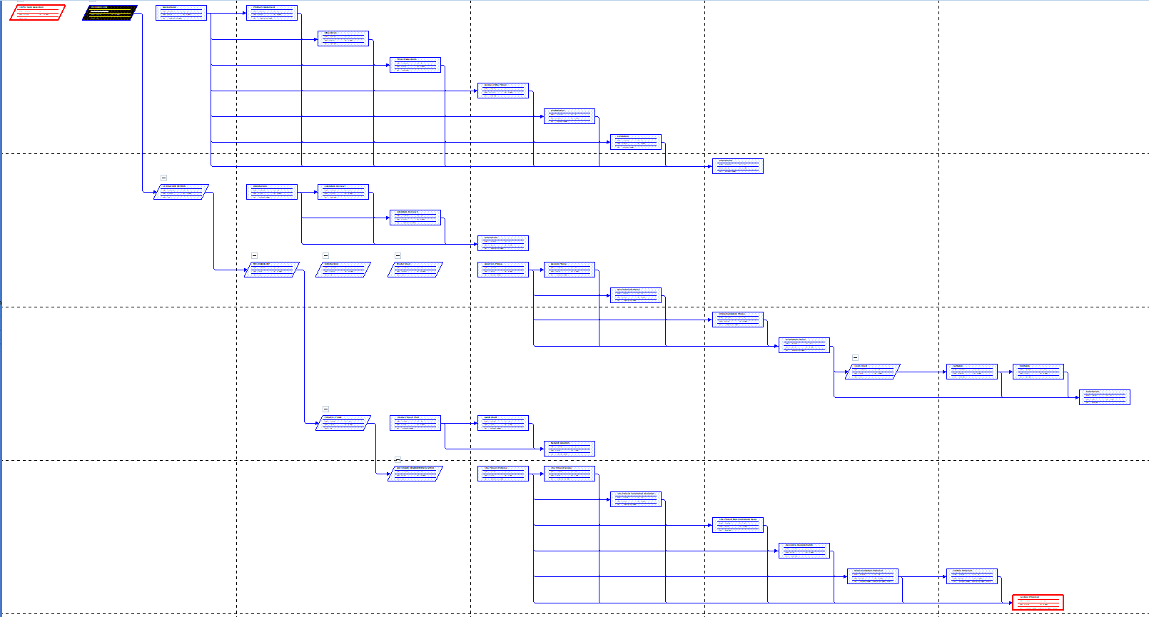

Figure 4.3: Network diagram.

# CHAPTER 5

## SOFTWARE REQUIREMENTS SPECIFICATION

### The Project Purpose:

The purpose of the project is to increase road safety and to reduce the number of accidents. The project goal is to detect a huge number of traffic signs such as obligatory signs, warning signs, preventive signs and Indicative signs. The system has the ability to work on different type of cars.



### The Project Scope:

The scope of this project is to identify different traffic signs from images during nighttime and daytime in real-time using an accurate and efficient manner.

### The Project Functional Requirements:

1. Detect the traffic signs.
2. Data processing: in this stage, each image will be processed before feeding the data into the model. Processing the data includes:

* Altering and cropping the image.
* Normalize and standardize the images.
* Applying segmentation
* Filtering and smoothing the images using Sharpening filter.

1. Splitting the data: splitting the data into validation group and training group.
2. Training the model: putting the processed and training data into the model of machine learning.
3. Evaluating the model: by using the validation group.
4. Producing the result of classification: this stage is for identifying the poor data classification.

### The Project Non –Functional Requirements:

The project non-functional requirements are:

* 1. Requirements of product:
* The performance: due to the use of CNN, analyzing the images is hugely accurate which aids to increase the performance of the system.
* The efficiency: in terms of time and memory, this system is efficient due to the use of CNN
* Portability: the system is able to work in all types of traffic sign and embedded systems.
* Maintenance: the system is easy in maintenance and supportability.
* Reliability: The system is reliable by 99% because no need for maintaining it in some specific day.
* Accuracy: the system has to detect the traffic sign in correct and accurate manner.
* Simple of Use: a user has ability to interact using the system in a simple way.
* Modularity: This system has to be modular. Every module may be removed or inserted.
* Robustness: the performance of the software is optimized. In a short time with almost correctness and relevancy, the results will be expected by the user.
  1. Organizational Requirements:
* Process Standards: IEEE models are used to construct the application, which is the standard used by the majority of standard programming designers worldwide.
* Methods of Design: The project's design is based on a modular approach.
  1. Fundamental Operational Needs:
* Mission profile or situation: The project's goal is to identify traffic signs.
* Situations of use: Any image of a traffic sign may be used.
  1. Operational life cycle:
* System Operation: Ensure that the system carries out the intended tasks as delineated in the design and development phases.
* Maintenance and Support: Resolve and correct any problems or defects that occur while the system is in use. Continue to assist users.
* Security and Compliance: Goal: Guarantee the system's continued security, adherence to legal requirements, and defense against dangers.
* User Training and Documentation: To help users make the most of the system, give them regular training and keep the documentation current.
* Backup and Recovery Planning: Put strong backup and recovery processes in place to guarantee data availability and integrity.

### Resource Requirements:

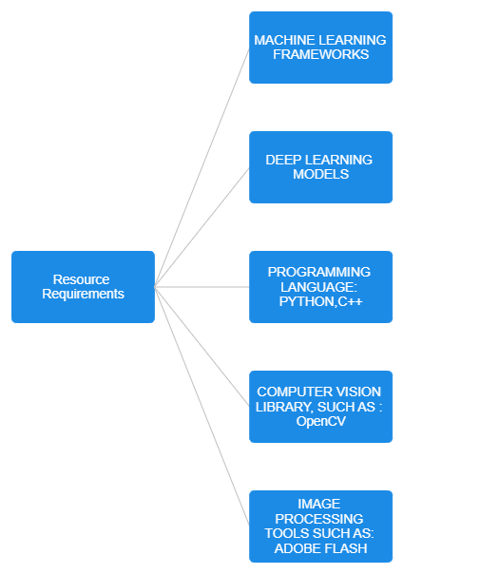

Figure 5.1: Resource requirements.

# CHAPTER 6



## THE DESIGN OF THE PROJECT

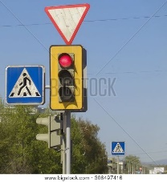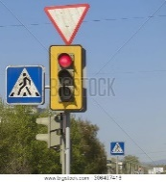This part is clearly describing the model design of this project. The design contains several stage, each of them are doing a significant process. It Starte by get the image input then this image will go through a number of process.

Figure 6.1:The design of the project.

# REFERENCES

[1 ]Llp, B. P. (2023). Inadequate road signage. Butler Prather LLP. https://www.georgiatruckaccidentattorneys.com/practice-areas/inadequate-road-signage/

[2 Forson, E. (2022). Recognising traffic signs with 98% accuracy using deep learning. Medium. https://towardsdatascience.com/recognizing-traffic-signs-with-over-98-accuracy-using-deep-learning-86737aedc2ab

[3]Ellahyani, A., Ansari, M. E., Jaafari, I. E., & Charfi, S. (2016). Traffic Sign Detection and Recognition using Features Combination and Random Forests. International Journal OF Advanced Computer Science and Applications,7(1). <https://doi.org/10.14569/ijacsa.2016.070193>

[4]G.BharathKumar,2.A.(2020).Trafficsign detection using.*IJCRT*,*8*(5),2635-2641.https://ijcrt.org/papers/IJCRT2005338.pdf

[5]Kundu, R. (2023). YOLO: Algorithm for Object Detection Explained [+Examples]. V7.https://www.v7labs.com/blog/yolo-object-detection#how-does-yolo-work-yolo-architecture

[6] Zhu, Z., Liang, D., Zhang, S., Huang, X., Li, B., & Hu, S. (2016). Traffic-sign detection and classification in the wild. In Proceedings of the IEEE conference on computer vision and pattern recognition (pp. 2110-2118).

[7] Wali, S. B., Abdullah, M. A., Hannan, M. A., Hussain, A., Samad, S. A., Ker, P. J., & Mansor, M. B. (2019). Vision-based traffic sign detection and recognition systems: Current trends and challenges. Sensors, 19(9), 2093.

[8] Chen, Z. Y., Lin, W. C., Ke, S. W., & Tsai, C. F. (2015). Evolutionary feature and instance selection for traffic sign recognition. Computers in Industry, 74, 201-211.

[9] Wu, Y., Liu, Y., Li, J., Liu, H., & Hu, X. (2013, August). Traffic sign detection based on convolutional neural networks. In The 2013 international joint conference on neural networks (IJCNN) (pp. 1-7). IEEE.

[10] Awati, R. (2023). convolutional neural network (CNN).Enterprise AI.https://www.techtarget.com/searchenterpriseai/definition/convolutional-neural-network

[11] Top 7 image datasets for object Detection. (2023).Datagen. <https://datagen.tech/guides/image-datasets/image-dataset-for-object-detection/>

[12] Intelligence, A. (2023). What are the most effective ways to preprocess images for segmentation and classification? www.linkedin.com. <https://www.linkedin.com/advice/0/what-most-effective-ways-preprocess-images>

[13] Ee Heng Chen, Philipp Röthig, Jöran Zeisler, Darius Burschka‏2019 IEEE Intelligent Transportation Systems Conference (ITSC), 325-332, 2019.‏<https://web.archive.org/web/20180411172043id_/https://www.fruct.org/publications/abstract20/filesKom.pdf>

[14] Yan Han, Kushal Virupakshappa, Esdras Vitor Silva Pinto, Erdal Oruklu‏Electronics 4 (4), 1062-1089,2015. <https://www.mdpi.com/2079-9292/4/4/1062>

[15] De Brucker, K., Macharis, C., & Verbeke, A. (2011). Multi-criteria analysis in transport project evaluation: an institutional approach. *European Transport*, *47*(47), 3-24

[16]De Brucker, K., Macharis, C., Wiethoff, M., & Marchau, V. (2014). Strategic analysis of stakeholder preferences regarding the design of ITS‐based road safety measures. *IET Intelligent Transport Systems*, *8*(3), 190-199

[17] Topolšek, D., Areh, I., & Cvahte, T. (2016). Examination of driver detection of roadside traffic signs and advertisements using eye tracking. *Transportation Research Part F: Traffic Psychology and Behaviour*, *43*, 212-224.

[18] Farhat, W., Faiedh, H., Souani, C., & Besbes, K. (2016). Real-time hardware/software co-design of a traffic sign recognition system using Zynq FPGA. In *2016 11th International Design & Test Symposium (IDT)* (pp. 302-307). IEEE.

[19] Arcos-García, Á., Álvarez-García, J. A., & Soria-Morillo, L. M. (2018). Evaluation of deep neural networks for traffic sign detection systems. *Neurocomputing*, *316*, 332-344.

[20] Arcos-García, Á., Álvarez-García, J. A., & Soria-Morillo, L. M. (2018). Evaluation of deep neural networks for traffic sign detection systems. *Neurocomputing*, *316*, 332-344.

[21] Vinh, T. Q. (2015). Real-time traffic sign detection and recognition system based on friendlyARM Tiny4412 board. In *2015 International Conference on Communications, Management and Telecommunications (ComManTel)* (pp. 142-146). IEEE.

[22] Welch, S., & Mann, R. (2001). The development of a benchmarking and performance improvement resource. *Benchmarking: An International Journal*, *8*(5), 431-452.

[23] Zotti, J. (2022, December 1). Tesla: 3 catalizzatori per le azioni in Borsa. Investire.biz. <https://investire.biz/news/azioni/tesla-borsa-wall-street>

[24] Ameen, M. A. (2023). Understanding Convolutional Neural networks (CNNs): best for image classification. <https://www.linkedin.com/pulse/understanding-convolutional-neural-networks-cnns-best-al-ameen>

[25] Adcidl.<https://www.adcidl.com/pdf/Omani-Road-Teraffic-Signs.pdf>

[26] Chiluka, S. R. Department of Mathematics and Natural Sciences Blekinge Institute of Technology <https://www.diva-portal.org/smash/get/diva2:1546486/FULLTEXT02.pdf>

[27] Dharmaraj. (2022). Convolutional Neural Networks (CNN) - architecture explained. *Medium*. <https://medium.com/@draj0718/convolutional-neural-networks-cnn-architectures-explained-716fb197b243>

[28] DeBell, A. (2023, January 10). *What is the ADDIE Model of Instructional Design? - Water Bear Learning*. Water Bear Learning. <https://waterbearlearning.com/addie-model-instructional-design/>

[29] Surinwarangkoon, T., Nitsuwat, S., & Moore, E. (n.d.-c). Traffic sign recognition by color filtering and particle swarm optimization. ResearchGate. <https://www.researchgate.net/publication/268336973_Traffic_Sign_Recognition_by_Color_Filtering_and_Particle_Swarm_Optimization>

[30] *ADDIE Model - Information Technology*. (2023). Information Technology. [https://www.uwb.edu/it/addie#:~:text=The%20acronym%20%E2%80%9CADDIE%E2%80%9D%20stands%20for,think%20through%20a%20course’s%20design](https://www.uwb.edu/it/addie#:~:text=The%20acronym%20%E2%80%9CADDIE%E2%80%9D%20stands%20for,think%20through%20a%20course's%20design).

[31] Nanos, G., & Nanos, G. (2023). *Object Detection: SSD Vs. YOLO | Baeldung on Computer Science*. Baeldung on Computer Science. [https://www.baeldung.com/cs/object-detection-ssd yolo#:~:text=As%20for%20performance%20issues%2C%20SSD,more%20suitable%20for%20his%20application](https://www.baeldung.com/cs/object-detection-ssd%20yolo#:~:text=As%20for%20performance%20issues%2C%20SSD,more%20suitable%20for%20his%20application).